**Name: _____________ IPad # _________**

**Topic #7**

**Kinetics and Reaction Rates**

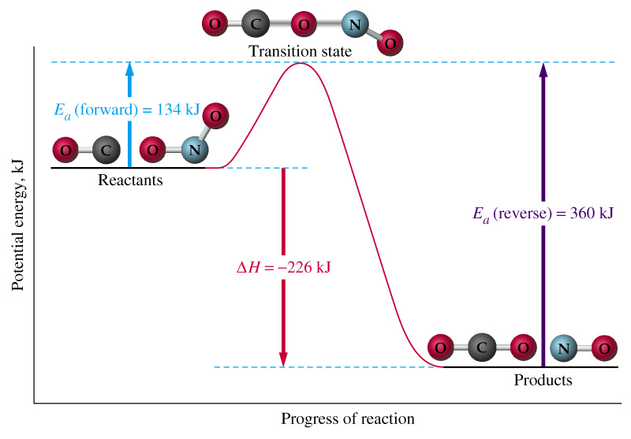

**Textbook Chapter 18**

**Homework Due:** _____________________

**Free response exam: __________________**

**Multiple Choice exam: ________________**

**Looking Ahead:**

**Quarterly Exam- Free Response: __________________**

**Quarterly Exam- Multiple Choice: ________________**

# Student Study Guide: Kinetics and Reaction Rates

1. Heat content **(H)** is defined as **enthalpy**.
2. Conservation of energy – energy is neither created nor destroyed

* All chemical reactions, either ***physical*** or ***chemical changes***, are represented by chemical equations showing reactants and products.

**Iron + sulfur -----> Iron II Sulfide**

**(reactants) (products)**

During any chemical changes, there will be changes in energy content.

**A.** If the reaction is **exothermic** the **energy value** is written on the **right side** of the

equation.

**Example:** **When *∆H (*the change in enthalpy*) is negative it is an exothermic reaction.***

***Going towards lower enthalpy.***

***Products Are More Stable Than The Reactants***

**2H2(g) + O2(g) -----> 2H2O(g) + Energy ∆H = -483.6kJ**

**Or**

**2H2(g) + O2(g) -----> 2H2O(g) + 483.6 KJ**

**B.** If the reaction is **endothermic**, the **energy value** is written on the **left side** of the

equation.

**Example: *When ∆H (*the change in enthalpy*) is positive it is an endothermic***

***reaction.***

***Going towards greater enthalpy.***

***Products Are Less Stable Than The Reactants***

**Energy + N2(g) + O2(g) -----> 2NO(g) ∆H = + 182.6 kJ**

**Or**

**182.6kJ + N2(g) + O2(g) -----> 2NO(g)**

1. Exothermic (energy released; reactants have more energy than products)

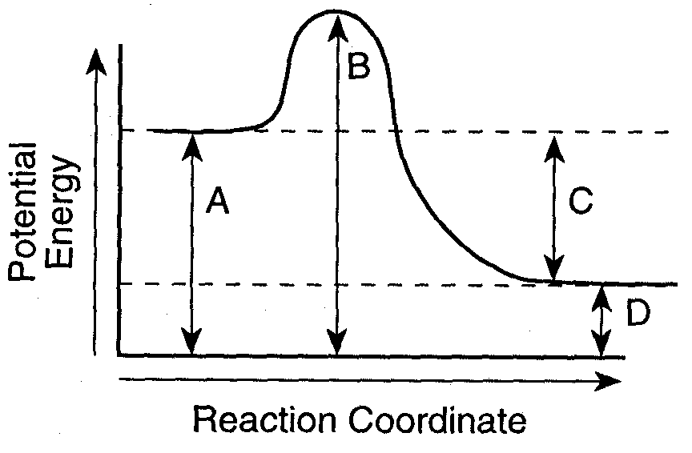

A= Potential energy reactants

B= Potential energy of the activated complex

C= ∆H (heat of reaction)

D= Potential energy products

* Endothermic(energy absorbed; products have more energy that reactants)

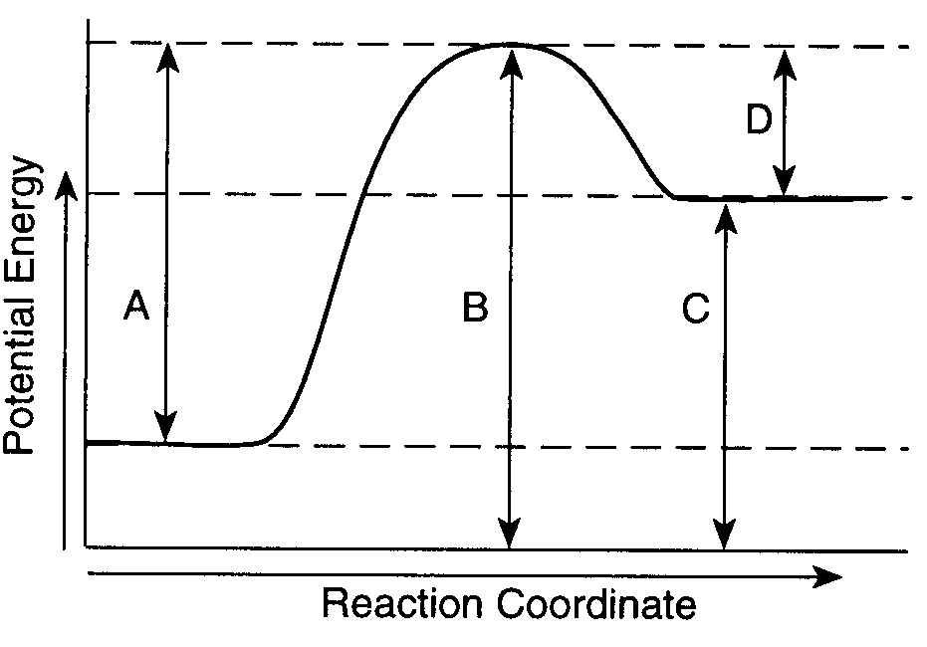

A= Activation energy of forward reaction

B= Potential energy of the activated complex

C= Potential energy products

D= Activation energy of reverse reaction

* **Factors affecting reaction rates are all based on the collision theory:** The greater number of effective collisions, the faster the reaction rate. These factors include:

1. **Nature of reactants** – types of bonding; ionic bonds in solution react faster than covalent
2. **Surface area** – The amount of one reactant exposed to another reactant
3. **Concentration** – the amount of a substance involved
4. **Temperature** – measure of ***kinetic energy*** (speed of the particles)

5. **Catalyst** ‑ lowers activation energy to speed up a reaction

* Predicting reactions’ behavior in terms of atoms, molecules and/or ions :

**Entropy (S)**= randomness or disorder

Changing phases from **(s) → (l) → (aq) → (g)** involves an increase in disorder or entropy.

**In general, two forces govern the behavior of chemical systems:**

**1-tendency toward minimum (lower) enthalpy (exothermic change)**

**2-tendency toward maximum (higher) entropy (state of greater disorder)**

**The combined effect of these changes is called “free energy change” (Gibbs Free Energy) 1-**

**Free energy of reaction** (**∆G)** equals to the change in the enthalpy (**∆H)** of the system minus the product of the temperature (Kelvin) and the change in the entropy (**∆S**) of the system:

**∆G = ∆H - T∆S**

Vocabulary

Heat of reaction energy kinetics

PE diagrams reaction mechanism reaction rate

PE of reactants enthalpy Spontaneous reaction

PE of products PE of activated complex exothermic reaction

Endothermic reaction activation energy Concentration

stability entropy

Collision theory nature of reactants surface area

**Kinetics and Reactions Rates Homework**

**Part I: Making Products-Colliding Particles**

Using your glossary, define ***collision theory.***

___________________________________________________________________________________________________________________________________________________________________________________________________

Look at the figures below. One shows a collision that results in the formation of product.  
Label it ***effective collision***. Label the other collision ***ineffective collision***.

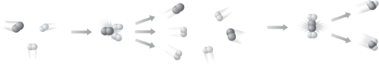

__________________ ____________________

List three conditions that will promote effective collision during a chemical change.

1. __________________________________________________________

2. __________________________________________________________

3. __________________________________________________________

**Page 601**

#4 _________________________________________________________________________

_______________________________________________________________

**Part II: Quick Review of Parts of a Chemical Equation**

**Fill in the blanks.**

* A _______________________ represents a chemical change.
* The _________________ are the substances you begin with before a chemical change has taken place.
* The _________________ are the substances you end with after a chemical change has taken place.
* A double-sided arrow represents a ___________reaction.
* An arrow facing upward at the end of a reaction represents _________________.
* An arrow facing downward at the end of a reaction represents _________________.

**Part III: Overall Change in Enthalpy (Heat Content) During a Chemical Change**

Using your glossary, differentiate the following terms***:***

|  |  |
| --- | --- |
| **Exothermic Process**  **In an exothermic chemical reaction, the energy is placed on the ______________ (reactant, product) side of the equation.** | **Endothermic Process**  **In an exothermic chemical reaction, the energy is placed on the ______________ (reactant, product) side of the equation.** |

Decide whether each of these reactions is ***exothermic***or ***endothermic***:

1. A solid burns brightly and releases heat, light and sound: ____________
2. When two chemicals are mixed their temperature drops: ___________
3. Plants take in light energy for photosynthesis: _______________

***Write the unbalanced equations for the following descriptions of chemical reactions. Include the energy term on the appropriate side of the chemical equation***.

1. When hydrogen peroxide is placed on a cut knee it decomposes to

form water and oxygen gas. **The ∆H = -200kJ.**

_________________________________________________________

2. Dissolving ammonium chloride in water creates an aqueous solution containing

ammonium and chloride ions. This solution feels cold and the **∆H = +14.7 kJ**.

________________________________________________________

**Part IV: Interpret Graphs- Potential Energy Diagrams**

**Page 597-Figure 18.5**

**Use the graph to answer the questions a through e.**

**a. Read Graphs: ________________________________________**

**b. Compare: _________________________________________________________________**

**________________________________________________________**

**c. Classify: Endothermic change ___________ Exothermic change ___________**

**How did you know?**

**__________________________________________________________________________________________________________________________________**

**d. Explain: __________________________________________________________________**

**________________________________________________________**

**e. Draw Conclusions: _________________________________________________________**

**Answer questions #1-9 using the potential energy diagram below:**



**A + B  C + D + energy**

1. Is the above reaction ***endothermic*** or ***exothermic***? ___________________

Explain why

_______________________________________________________________________

1. What letter represents the **potential energy of the reactants**? ______________
2. What letter represents the **potential energy of the products**? ______________
3. What letter represents the **heat of reaction (ΔH)**? _______________
4. Draw an arrow to represent the **activation energy** of the forward reaction.

**Label the arrow E**

1. Draw an arrow to represent the **activation energy** of the reverse reaction.

**Label the arrow F**

1. What letter represents the **potential energy of the activated complex**? ________
2. Is the reverse reaction **exothermic** or **endothermic**? ____________________
3. The letters **A+B** and **C+D** represent what parts of a chemical reaction?

_________________ and ____________________

**Page 638**

#55 ________________________________________________________________________

______________________________________________________________

**Answer questions #1-9 using the potential energy diagram below:**

**\*Assume energy is measured in kilojoules**

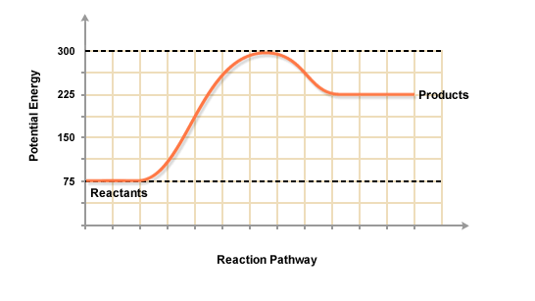

1. Is the above reaction ***endothermic*** or ***exothermic***? ___________________

Explain why.

______________________________________________________________________

1. The reactants started with how much stored energy? ______________kJ
2. The products ended with how much stored energy? ______________kJ
3. Determine the value of **∆H** of the reaction. ______________kJ
4. How much energy in needed to activate the forward chemical reaction? ___________kJ
5. How much energy in needed to activate the reverse chemical reaction? ___________kJ
6. At the activated complex, the potential energy is equal to _________kJ

**Page 639**

#85 ________________kJ

#86 In the box below, sketch the potential energy diagram.

**Part V: Measuring Randomness- Entropy**

Using your glossary, define ***entropy.***

__________________________________________________________________________________________________________________________________

**Pearsons SuccessNet On-line**

**Chapter 18 🡪 Concepts in Action: Entropy-Gone to the Dogs**

**Explore the model illustrating entropy and answer questions online.**

**Page 638-639**

#76 a. ____________________________________________

b. ____________________________________________

#87 _______________________________________________________________________

#88 a. _________________________

Explain why

_______________________________________________________________________

b. _________________________

Explain why

_______________________________________________________________________

c. _________________________

Explain why

_______________________________________________________________________

d. _________________________

Explain why

_______________________________________________________________________

**Part VI: Slowing Down or Speeding Up- Rates of Chemical Reactions**

All Group 2 metals react with dilute hydrochloric acid to give bubbles of hydrogen and a colorless solution of the metal chloride.

List 4 ways you would use to increase the rate of the following reaction.

**Mg(s) + HCl(aq) ----> H**2**(g) + MgCl**2**(s) + energy**

1. __________________________________________________

2. __________________________________________________

3. __________________________________________________

4. ___________________________________________________

**Page 601**

#5 __________________________________________________________________________

**Page 638**

# 56 ____________

**\*Refer to pages 600-601 in the textbook**

What does a catalyst do?

_________________________________________________________________

**The graph below shows the reaction rate of the same reaction with and without a catalyst. Use it to help you answer the following questions.**

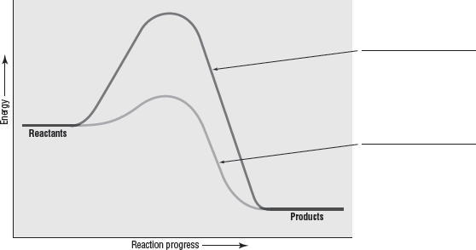

a. Label each curve as ***with catalyst***or ***without catalyst***.

b. What does the graph show about the effect of a catalyst on the rate of a reaction?

_________________________________________________________________________

c**.** In a **chemical equation**, how do you show that catalysts are not consumed or chemically  
 altered during a reaction?

_________________________________________________________________________

d.A(n) ______________________ is a substance that interferes with the action of a catalyst.

**Page 640 - 641**

#102 a. ________________________________________________________________

b. _______________________________________________________________

c. ________________________________________________________________

#107 _______________________________________________________________________

_______________________________________________________________________

#110 _______________________________________________________________________

_______________________________________________________________________

**CHEMYSTERY-Explosive Sugar**

#112 _______________________________________________________________________

_______________________________________________________________________

#113 _______________________________________________________________________

_______________________________________________________________________

**Part VII: Extension- Free Energy and Spontaneous Reactions**

The tendency for a reaction to occur depends on both the change in enthalpy (**Δ**H) and change in entropy (**Δ**S). In a spontaneous reaction, **ΔH** is **negative** and **ΔS** is **positive** for a reaction. If **ΔH** is **positive** and **Δ**S is **negative** for a reaction, the reaction *will not* occur and is classified as nonspontaneous. How can you predict what will happen if **Δ**H and **Δ**S are both positive or both negative?

Josiah Willard Gibbs, a professor from Yale University, answered that question by proposing anther thermodynamic quantity, which now bears his name. Gibbs energy is represented by the symbol G and is defined by the following equation: **ΔG = ΔH -TΔS.** Another name for Gibbs energy is *free energy*.

Gibbs energy determines spontaneity. When the term ***spontaneous*** is used to describe reactions, it has a different meaning than the meaning that we use to describe other events. A spontaneous reaction is one that does occur or is likely to occur without continuous outside assistance. For example, an avalanche is a good example of a spontaneous process. On mountains during winter, an avalanche may or may not occur, but it always *can* occur. The return of the snow from the bottom of the mountain to the mountaintop is a nonspontaneous event, because this event will not happen without aid.

A reaction is spontaneous if the Gibbs energy change is negative. If a reaction has a **Δ**G greater than 0, the reaction is nonspontaneous. If a reaction has a **Δ**G of exactly zero, the reaction is at equilibrium.

1. Define Gibbs energy.

____________________________________________________

1. Using the equation in the article, solve the following problem:

Give that the changes in enthalpy and entropy are -139 kJ and

277 J/K respectively for the reaction given below, calculate the change in Gibbs energy. Then, state whether the reaction is spontaneous at 250C.

**C6H12O6(aq) ----> 2C2H5OH(aq) + 2CO2(g)**

This reaction represents the fermentation of glucose into ethanol (C2H5OH) and carbon dioxide, which occurs in the presence of enzymes provided by yeast cells. This reaction is used in baking.

|  |
| --- |
|  |

1. Relating Enthalpy & Entropy changes to Spontaneity (**ΔG = ΔH -TΔS)**

Complete the following table:

|  |  |  |  |
| --- | --- | --- | --- |
| **ΔH** | **ΔS** | **ΔG** | **Is the reaction spontaneous?** |
| **Negative** | **Positive** | **Negative** |  |
| **Negative** | **Negative** | **Either positive or negative** | Describe temperature conditions: __________ |
| **Positive** | **Positive** | **Either positive or negative** | Describe temperature conditions: __________ |
| **Positive** | **Negative** | **Positive** |  |

**Page 634**

# 47 _______________________________________________________________________

_______________________________________________________________________

# 49 ________________________________________________________________________

#53 ________________________________________________________________________

________________________________________________________________________

________________________________________________________________________